
ROTARY CLUB OF CHIPPING CAMPDEN
& DISTRICT
(Charity Number 1027584)

The Tree of Light will be switched on at Chipping Campden
Christmas Market 5th December 2026, please join us for the event.

I wish to sponsor the Chipping Campden Tree of Light in memory of:

Over the page we would like to invite you to share a short story, memory, or interesting fact about your loved one. We hope to include stories in a memorial book on our website.
- A suggested minimum of £5 per name is requested, or whatever you wish to contribute.
- If paying cash or cheque, payable to the Rotary Club of Chipping Campden, please return this form to Peter Clarke’s Estate Agent, Chipping Campden.
- To pay by card please visit our website www.rotary.chippingcampden.net/cms/tree or visit Peter Clarke’s Estate Agent, Grafton House, High Street, Chipping Campden.

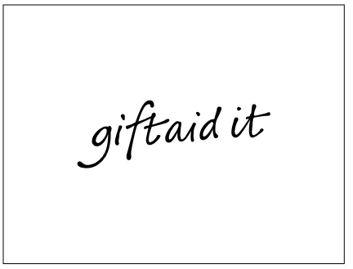
Use Gift Aid and you can make your donation worth more. For every £1 you give to us, we get an extra 25p from the Inland Revenue. So just tick the box below. It’s that simple.
All donations I make from the date
of this declaration until I notify you
otherwise are eligible for gift aid.

YOUR NAME……………………………………. DATE:………………………………..
ADDRESS……………………………………………………………………………………………………………………………………………………………………………………………………………….. POSTCODE……………………………….
EMAIL: …………………………………….
Signature: ………………………………..
We will use the details provided to update your record and to process your donations to us, our privacy policy is available on our website. Please note: The Rotary Club can only claim Gift Aid if you provide your full first name, surname and home address.
Please tick here if you wish us to keep in touch about other Rotary events and activities in the local area

Write a few words or memories about the person you are remembering, what would you like people to know about them?

